ALASKA TRIBAL VOCATIONAL REHABILITATION (TVR) PROGRAMS AMERICAN INDIAN VOCATIONAL REHABILITATION SERVICES (AIVRS) GRANTEES

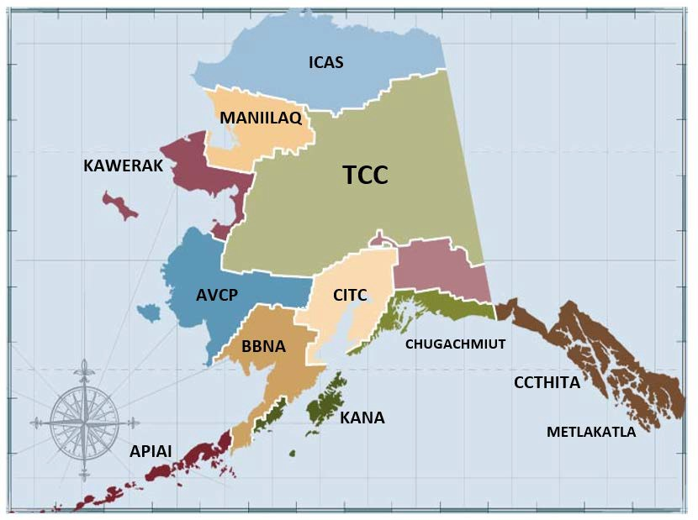

 | Kawerak, Inc.  Sara Lizak:  Slizak@kawerak.org  (907) 443-4362 |  | Association of Village Council Presidents - AVCP  Irma Goodwine:  Igoodwine@avcp.org  (907) 543-7451
 | Tanana Chiefs Conference - TCC  Amanda Race: Amanda.race@tananachiefs.org  (907) 452-8251 x 3232 |  | Bristol Bay Native Association - BBNA  Gail Sorensen: gsorensen@bbna.com  (907) 842-2262
 | Metlakatla Indian Community  Franki A. Williams:  fwilliams@metlakatla.com  (907) 886-5872, 5873, 5874 |  | Aleutian Pribilof Islands Association, Inc. – APIA  Angie Santa Ana:  angies@apiai.org  (907)-222-9732
 | Cook Inlet Tribal Council, Inc.- CITC  Mahala Coker:  Mahala.Coker@citci.org  800-478-3312 |  | Inupiat Community of the Arctic Slope – ICAS  Jennifer Brower:  Jennifer.Brower@icas-nsn.gov  (907) 852-8147, 888-734-2448
 | Kodiak Area Native Association - KANA  Maggy Shirley Maggy.Shirley@kodiakhealthcare.org (907) 486-7309, 800-478-5721 |  | Central Council of Tlingit & Haida Indian Tribes of Alaska - CCTHITA  Teresa Sarabia: tsarabia@tlingitandhaida.gov  (907) 463-7325
 | Maniilaq Association  Charlene Hadley:  chadley@maniilaq.org  907-494-2122, Work 800-504-2268 |  | Chugachmiut  Christine Sundly:  csundly@chugachmiut.org  907-562 4155 ext. 111

Rev. Feb. 09, 2026

