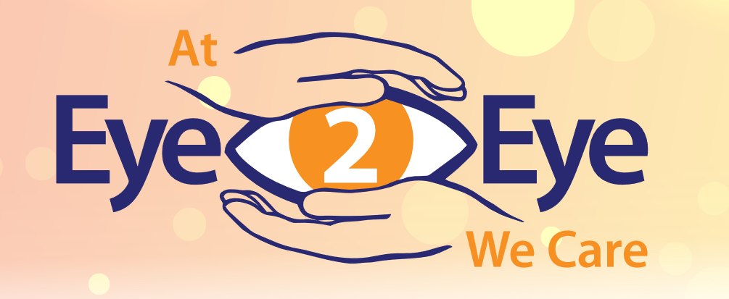

## ****Eye2Eye is a free, phone-based, peer support program, designed to assist individuals who are blind or visually impaired.****

## The program offers:

* Emotional Support
* Community Connection
* Assessments of Needs and Wellbeing
* Peer Support Groups
* Goal Setting
* Information and Resources
* Referrals
* Services for Families and Loved Ones
* Special Program for Older Adults in NYC

Eye2Eye focuses on the shared experience of vision loss as a powerful tool for connection, emotional support, and personal growth. Callers will be matched with trained peer support specialists who are also blind or visually impaired.

Eye2Eye is here to help build resilience, navigate the challenges of vision loss and celebrate victories one step at a time.

## Our peer support specialists are ready to help

### Contact us:

* (833) 932-3931
* [eye2eye@shp.rutgers.edu](mailto:eye2eye@shp.rutgers.edu)

### Follow us:

* **Twitter:** @eye2eyeps
* **Facebook:** Eye2Eye Peer Support

### Visit our website to learn more

<https://eye2eye.rutgers.edu/>